Task 1) - Fist they will have to cross check the cost and benefit data that they’ll need (3 Days)   
 - Then send an e-mail message to the Town Council, and requesting that the proposal be placed on (1 Day) & Develop the proposal itself, including necessary documents and charts (5 Day)

* After finished proposal print copies of handout material for the meeting (2 Days) & Develop a power point presentation (5 Days)
* When presentation is ready, conduct a rehearsal for the council meeting (2 Days)
* After rehearsal is done, help Dawn deliver the presentation. (1 Day)

Task 2) There is four task that are dependent on another task and that would be task 2(e-mailing town council) & task 3(developing a proposal). Those two tasks are depending on each other and without those being completed you will not be able to move forward. Then the next two task that are dependent on each other is task 4(print copies) & task 5(develop PowerPoint presentation).

Task 3) 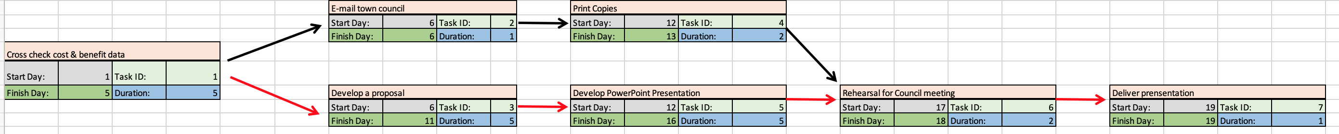

Task 4) The critical path of this project is 1,3,5,6,7. This is the critical path because task 3 & 5 have a longer duration than task 2 & 4, so those task will take longer to complete and without those you will not be able to move forward in your project.

Task 5) The total duration of the project will be 19 days long.